Budget
The target budget for one complete Spyder is £60 - £80 maximum.
This budget goes to parts you need to purchase that we don’t have on hand
Ideally, the robot is being designed as a six-legged hexapod, with two possible configurations:
- 2 DOF per leg: 12 servos total for a simpler and lighter design
- 3 DOF per leg: 18 servos total for greater control of each foot, but increased weight, power consumption and of course cost
Normally, we do 18 servos, but the budget being limited this year means there’s more leeway to the configuration you want to use.
After you complete your CAD design, let us know the parts you want to use, we’ll discuss it with you, and then order it. Normally orders from Aliexpress take about 2 to 3 weeks, so in the meantime while waiting for the parts to arrive, you should work on the simulation and coding.

Logic Controller
For a six-legged hexapod, the controller acts as the brain of the spider, and is normally connected to a dedicated servo driver such as the PCA9685, as this ensures the controller doesn’t need to manage up to 18 dedicated servo outputs.
You have a few options for your controller:
- Raspberry Pi - gives considerable computing capability than a basic microcontroller and allows the robot to run programs in languages such as Python. Software and debugging can run directly on the robot
- Arduino Uno - simpler microcontroller which can handle the necessities to drive servos while being pretty simple to program in
- ESP32 - cheap and very simple to work with, but is pretty low power, so this only really works if you’re doing a smaller 4-legged design

Servo Controller
A servo controller is used to act as a dedicated I/O device for the servos, without having to do complicated wiring and coding to run all the servos directly from the logic controller. The PCA9685 is a 16-channel PWM servo controller, meaning it can control up to 16 servos directly. If you want to control 18 servos, you can either just purchase two PCA9685s and connect them or look into higher-channel servo controllers.

Servos
Unlike a normal DC motor, a servo can be commanded to move to a particular angular position. For the larger six-legged design, consider servos such as the MG996R class because the servos must produce enough torque to support the robot's weight while also moving the legs. Ensure you use a 180 degree servo, as 360 degree servo don’t typically provide the needed control.

A servo doesn't simply need to move the leg. When the robot is standing, some of the servos must support a significant portion of the entire robot's weight. The further the foot is from the servo, the greater the torque required, using the equation below

$τ=rFsin(θ)$

For instance, with this set-up
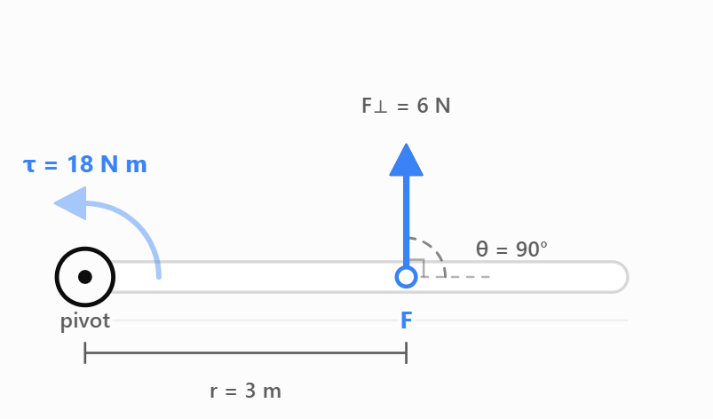
$τ=(3)(6)sin(90^{∘})=18Nm$
The perpendicular part of F turns the lever.

If a joint is supporting an equivalent load of 0.5 kg at 10 cm, a simple first estimate is
T = 0.5 x 10 = 5 kg·cm
In this scenario, you shouldn’t select a servo whose advertised stall torque is exactly 5 kg·cm. The design needs considerable headroom for acceleration, impacts, imperfect weight distribution and the fact that operating continuously near stall is undesirable. You have to calculate the expected leg torque and then give leeway for safety.

The MG996R is a commonly used metal-geared hobby servo and is a useful starting point for this larger design.
Typical spec figures for it are roughly:
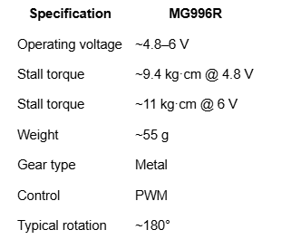
However, this torque comes with a notable downside, that being the weight. At 55 grams each, just 12 servos could weigh 0.66 kg. Adding more powerful servos increases the torque, but also increases the weight those servos need to support, which is something to be mindful of. Weight is a hard factor to consider for this design, since a slight adjustment could throw off the balance of the robot. Ultimately, you just need to figure it out as you go, since something will almost certainly go wrong.

Twelve large servos can produce very large current spikes when several joints start moving simultaneously. The power system therefore needs to be designed around the worst realistic combination of servo loads, not just the controller's current consumption. It’s much safer to connect the servos to the battery separately from the servo controller using a step-down converter.

Battery
A 2S LiPo battery provides approximately 7.4 nominal voltage. This is too high to feed typical 5–6 V micro servos directly, so a voltage regulator is required. A battery around 1500–2200 mAh should provide a reasonable starting point for prototype testing. We have batteries in storage, so we might not need to order any extra.

Voltage Regulator and Servo Power
A high-current 5 V DC-DC converter reduces the battery voltage to the voltage required by the servos and electronics. Servo power should not be taken through the Raspberry Pi.
The structure should follow a rough arrangement of:
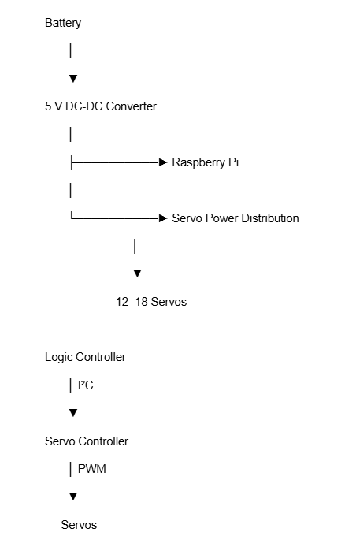

All parts of the system must have an appropriate common ground.

Budget
Ultimately, there’s a bit of flexibility, but we ideally need something within a 60 to 80 pound budget range. The general price chart for the baseline components is seen below:
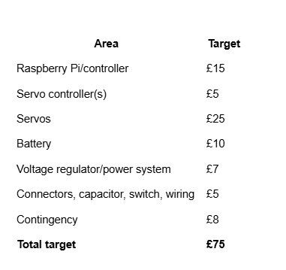
But it comes down to what parts you need and what servo design you choose. Look on Aliexpress for the parts you might need after designing your CAD and we can sort it out with you.

